BLACKSTAR AI + LYRICPILOT
Technical Architecture Plan
UML product maps • Python schema • database schema • ML schema • deployment architecture

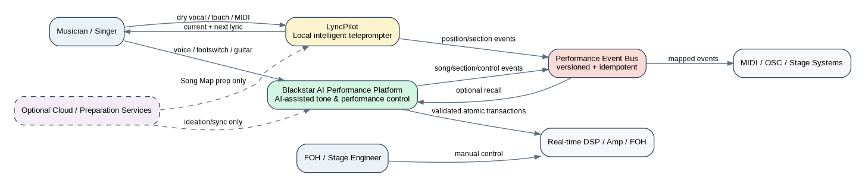
Figure 1. Combined product system context
Architecture baseline derived from Blackstar PID v1.0, dated 29 August 2026.

1. Executive architecture decision
The programme should be engineered as two independently releasable products sharing contracts, event semantics and performance-domain data, not as one tightly coupled application. Blackstar AI owns natural-language-to-safe-tone control; LyricPilot owns local sung-position tracking and display. The shared Performance Event Bus is an optional integration seam rather than a runtime dependency for either V1 product.
The core safety pattern is a two-stage authority model. Probabilistic components may interpret language, speech or acoustic evidence, but they never directly change DSP state or invent live lyric content. Blackstar commits changes only through the deterministic Tone Compiler, Validator and atomic DSP bridge. LyricPilot commits display movement only through constrained Song Map candidates, jump protection and a tracking state machine.

2. Architecture principles and non-functional constraints
Principle | Engineering consequence | Primary control
Local-first show operation | No critical network dependency; required assets preflighted and frozen | Performance Lock + checksum manifest
Probabilistic / deterministic separation | ML output is evidence or structured intent, not stage authority | Compiler/Validator or Position state machine
Independent fail-safe domains | AI host failure must not interrupt guitar audio/manual controls | DSP + MCU separation
Schema-first integration | Every boundary has a versioned typed contract | performance-contracts repository
Observable by design | Every state change has timestamps, versions and correlation IDs | append-only event log + replay bundle
Fail useful | Hold known-good tone/lyrics rather than guess | rollback / HOLD / MANUAL modes
Version everything | Models, ontology, Song Maps, presets, corpus and event contracts are immutable versions | hashes + manifests + migration policy

3. UML product maps

3.1 Blackstar AI component map
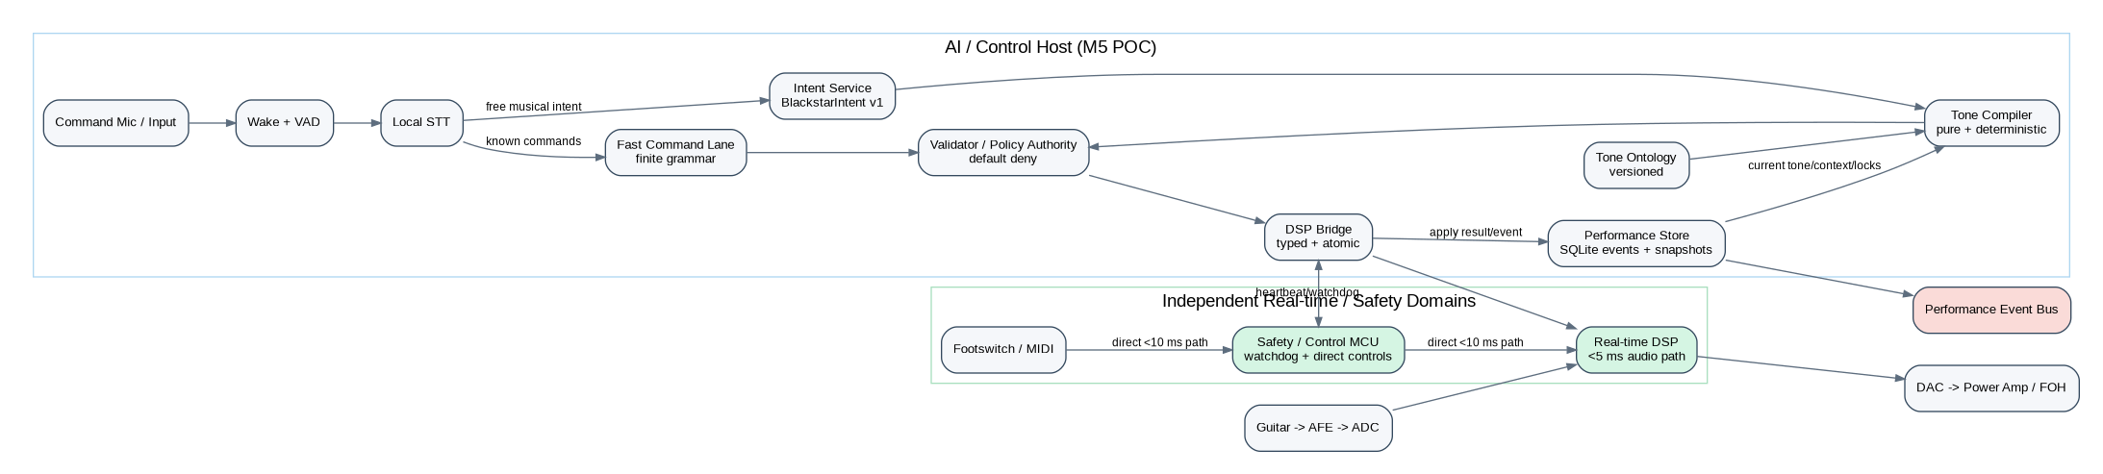
Figure 2. Blackstar AI logical component architecture
The guitar audio path remains entirely inside the real-time DSP domain. The M5-class host handles asynchronous speech and intent processing. A fast command lane bypasses heavyweight inference for known stage commands. Both free-form intent and fast commands converge on deterministic validation before any typed transaction reaches the DSP.

3.2 LyricPilot component map
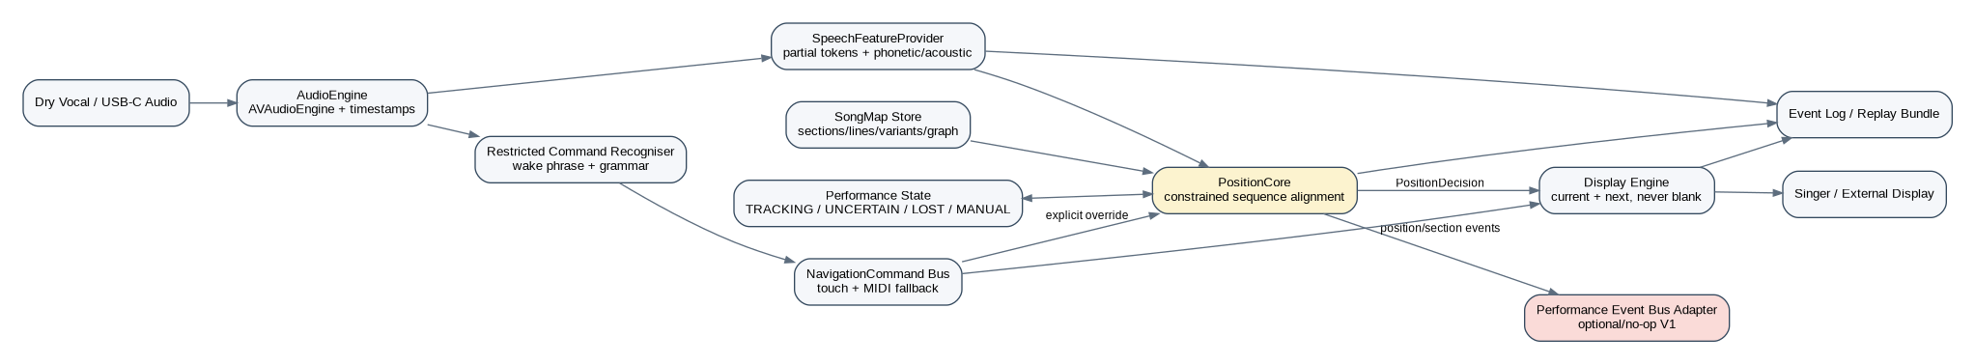
Figure 3. LyricPilot logical component architecture
LyricPilot is a constrained state-estimation product. Speech text is just one feature; it never directly drives the display. PositionCore considers a bounded candidate window in the approved Song Map, fuses multiple evidence scores and only emits a committed PositionDecision after state-machine and jump-safety logic.

3.3 Shared performance-domain class model
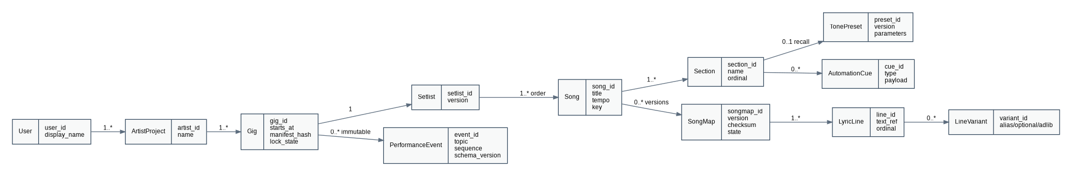
Figure 4. UML-style shared domain class model

3.4 Blackstar command sequence
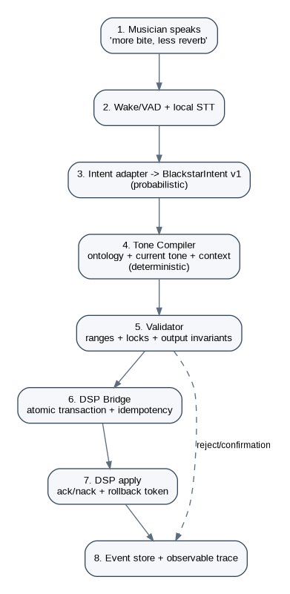
Figure 5. Blackstar intent-to-DSP sequence

3.5 LyricPilot tracking sequence
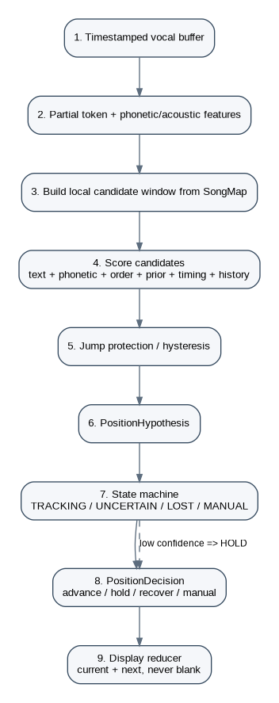

Figure 6. LyricPilot feature-to-display sequence

4. High-level Python code schema
Python is proposed for the shared contracts, POC orchestration, evaluation harnesses, simulators and ML adapters. Production LyricPilot remains native Swift/SwiftUI, while production DSP/MCU code remains in the appropriate real-time/embedded languages. The Python schema below defines domain boundaries rather than prescribing the final implementation language of every component.
Package | Responsibility | Key interfaces/classes
contracts | Versioned domain DTOs and JSON/protobuf compatibility | BlackstarIntent, ProposedDSPTransaction, ValidationResult, PerformanceEvent
speech | Wake/VAD/STT adapters and replay providers | WakeDetector, SpeechRecognizer, FeatureFrame
intent | Model-agnostic intent adapters | IntentAdapter.interpret()
tone_ontology | Dimensions, aliases, units, constraints, locks | OntologyRepository
tone_compiler | Pure deterministic compilation | ToneCompiler.compile()
validator | Safety and Performance Mode policy authority | Validator.validate()
dsp_bridge | Atomic apply/rollback, simulator and telemetry | DSPBridge.apply_atomic()
performance_domain | Gig/setlist/song/section aggregate and manifests | GigPackage, PerformanceLock
event_store | Append-only events, snapshots, undo/restore | EventStore
position_core | Candidate scoring, transition model, state machine | CandidateScorer, PositionCore
evaluation | Corpus replay, metrics and gate reports | ReplayRunner, MetricCalculator

from __future__ import annotations
from dataclasses import dataclass, field
from enum import Enum
from typing import Protocol, Sequence, Mapping, Any
from uuid import UUID
from datetime import datetime

class TrackingState(str, Enum):
TRACKING = "tracking"
UNCERTAIN = "uncertain"
LOST = "lost"
MANUAL = "manual"

@dataclass(frozen=True)
class SemanticDelta:
dimension: str # gain, spectrum, dynamics, space, monitor, etc.
operation: str # increase/decrease/set
amount: float
unit: str | None = None

@dataclass(frozen=True)
class BlackstarIntent:
intent_id: UUID
timestamp: datetime
semantic_deltas: Sequence[SemanticDelta]
locks: Sequence[str]
context: Mapping[str, Any]
confidence: float
requested_action: str
source: str
model_id: str

@dataclass(frozen=True)
class ProposedDSPTransaction:
transaction_id: UUID
base_preset_version: str
parameter_changes: Mapping[str, float]
routing_changes: Mapping[str, Any] = field(default_factory=dict)
monitor_changes: Mapping[str, Any] = field(default_factory=dict)
safety_metadata: Mapping[str, Any] = field(default_factory=dict)
compiler_version: str = "v1"

@dataclass(frozen=True)
class ValidationResult:
accepted: bool
violations: Sequence[str]
confirmation_required: bool
safe_transaction_hash: str | None

class IntentAdapter(Protocol):
def interpret(self, transcript: str, context: Mapping[str, Any]) -> BlackstarIntent: ...

class ToneCompiler(Protocol):
def compile(self, intent: BlackstarIntent, current_tone: Mapping[str, float],
ontology_version: str) -> ProposedDSPTransaction: ...

class Validator(Protocol):
def validate(self, tx: ProposedDSPTransaction, policy: Mapping[str, Any]) -> ValidationResult: ...

class DSPBridge(Protocol):
def apply_atomic(self, tx: ProposedDSPTransaction) -> Mapping[str, Any]: ...

@dataclass(frozen=True)
class FeatureFrame:
timestamp_ms: int
partial_tokens: Sequence[str]
token_confidence: Sequence[float]
phonetic_vector: Sequence[float]
acoustic_vector: Sequence[float]

@dataclass(frozen=True)
class PositionHypothesis:
song_id: UUID
line_id: UUID
section_id: UUID
confidence: float
runner_up_margin: float
evidence_scores: Mapping[str, float]
state: TrackingState
timestamp_ms: int

@dataclass(frozen=True)
class PositionDecision:
action: str # advance/hold/recover/manual
committed_line_id: UUID
reason_code: str
confidence: float
timestamp_ms: int

class CandidateScorer(Protocol):
def score(self, frame: FeatureFrame, candidate: Mapping[str, Any], context: Mapping[str, Any]) -> Mapping[str, float]: ...

class PositionCore(Protocol):
def update(self, frame: FeatureFrame) -> PositionDecision: ...

class PerformanceEventBus(Protocol):
def publish(self, topic: str, payload: Mapping[str, Any], idempotency_key: str) -> None: ...

5. Database architecture and schemas
SQLite is the correct POC and live local-store baseline because the PID explicitly calls for local performance operation and an event store. The logical schema separates configuration/master data, immutable live events and materialised state. If a future cloud catalogue or fleet service is added, the same identifiers and event contracts can be projected into PostgreSQL without changing the show-critical local model.
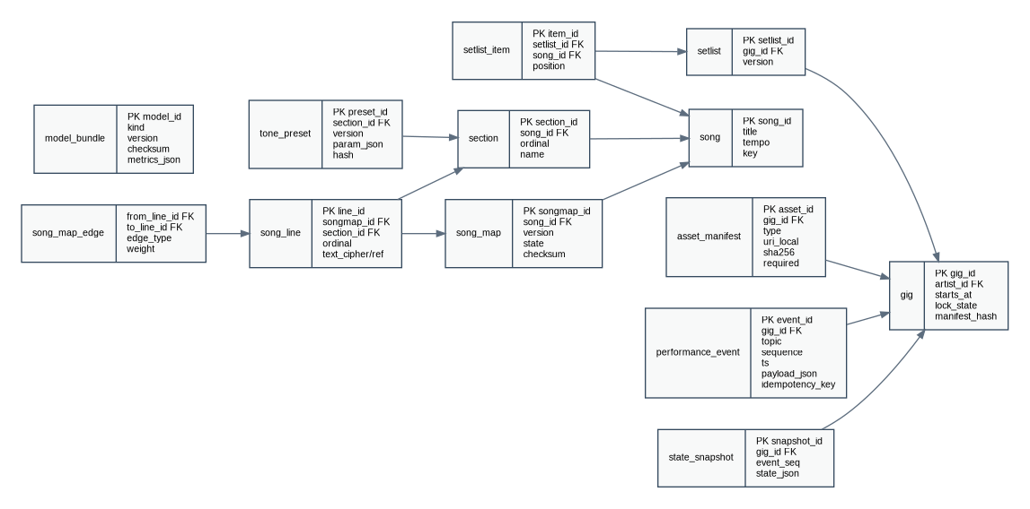
Figure 7. Core relational ERD
Data zone | Tables / objects | Retention / mutation rule
Performance master | artist_project, gig, setlist, setlist_item, song, section | Editable only outside Performance Lock
Blackstar tone state | tone_preset, preset versions, DSP transaction payloads | Versioned; applied versions immutable
LyricPilot arrangement | song_map, song_line, line_variant, song_map_edge | Draft -> Approved -> Locked lifecycle; no live mutation
Asset integrity | asset_manifest, model_bundle | Checksummed; required assets must pass preflight
Operational evidence | performance_event, evaluation_run | Append-only; correlation IDs and version metadata
Recovery state | state_snapshot | Atomic checkpoint tied to event sequence

5.1 SQL baseline

-- POC baseline: SQLite; portable to PostgreSQL if cloud/library services are added.
PRAGMA foreign_keys = ON;

CREATE TABLE artist_project (
artist_id TEXT PRIMARY KEY, name TEXT NOT NULL, created_at TEXT NOT NULL
);
CREATE TABLE gig (
gig_id TEXT PRIMARY KEY, artist_id TEXT NOT NULL REFERENCES artist_project(artist_id),
starts_at TEXT, venue TEXT, lock_state TEXT NOT NULL DEFAULT 'draft', manifest_hash TEXT
);
CREATE TABLE song (
song_id TEXT PRIMARY KEY, title TEXT NOT NULL, artist_name TEXT, tempo_bpm REAL, musical_key TEXT
);
CREATE TABLE setlist (
setlist_id TEXT PRIMARY KEY, gig_id TEXT NOT NULL REFERENCES gig(gig_id), version INTEGER NOT NULL
);
CREATE TABLE setlist_item (
item_id TEXT PRIMARY KEY, setlist_id TEXT NOT NULL REFERENCES setlist(setlist_id),
song_id TEXT NOT NULL REFERENCES song(song_id), position INTEGER NOT NULL,
UNIQUE(setlist_id, position)
);
CREATE TABLE section (
section_id TEXT PRIMARY KEY, song_id TEXT NOT NULL REFERENCES song(song_id),
name TEXT NOT NULL, ordinal INTEGER NOT NULL
);
CREATE TABLE tone_preset (
preset_id TEXT PRIMARY KEY, section_id TEXT REFERENCES section(section_id), version INTEGER NOT NULL,
parameter_json TEXT NOT NULL, checksum TEXT NOT NULL
);
CREATE TABLE song_map (
songmap_id TEXT PRIMARY KEY, song_id TEXT NOT NULL REFERENCES song(song_id), version INTEGER NOT NULL,
lifecycle_state TEXT NOT NULL CHECK(lifecycle_state IN ('draft','approved','locked')),
checksum TEXT NOT NULL, UNIQUE(song_id, version)
);
CREATE TABLE song_line (
line_id TEXT PRIMARY KEY, songmap_id TEXT NOT NULL REFERENCES song_map(songmap_id),
section_id TEXT NOT NULL REFERENCES section(section_id), ordinal INTEGER NOT NULL,
lyric_ref TEXT NOT NULL, canonical_tokens_json TEXT, UNIQUE(songmap_id, ordinal)
);
CREATE TABLE line_variant (
variant_id TEXT PRIMARY KEY, line_id TEXT NOT NULL REFERENCES song_line(line_id),
variant_type TEXT NOT NULL, token_form_json TEXT NOT NULL
);
CREATE TABLE song_map_edge (
from_line_id TEXT NOT NULL REFERENCES song_line(line_id),
to_line_id TEXT NOT NULL REFERENCES song_line(line_id), edge_type TEXT NOT NULL,
transition_weight REAL NOT NULL DEFAULT 1.0, PRIMARY KEY(from_line_id,to_line_id,edge_type)
);
CREATE TABLE asset_manifest (
asset_id TEXT PRIMARY KEY, gig_id TEXT NOT NULL REFERENCES gig(gig_id), asset_type TEXT NOT NULL,
local_uri TEXT NOT NULL, sha256 TEXT NOT NULL, required INTEGER NOT NULL DEFAULT 1
);
CREATE TABLE performance_event (
event_id TEXT PRIMARY KEY, gig_id TEXT REFERENCES gig(gig_id), source TEXT NOT NULL,
topic TEXT NOT NULL, sequence INTEGER NOT NULL, event_time TEXT NOT NULL,
schema_version TEXT NOT NULL, payload_json TEXT NOT NULL, idempotency_key TEXT NOT NULL UNIQUE
);
CREATE INDEX idx_event_gig_seq ON performance_event(gig_id, sequence);
CREATE TABLE state_snapshot (
snapshot_id TEXT PRIMARY KEY, gig_id TEXT NOT NULL REFERENCES gig(gig_id),
event_sequence INTEGER NOT NULL, state_json TEXT NOT NULL, created_at TEXT NOT NULL
);
CREATE TABLE model_bundle (
model_id TEXT PRIMARY KEY, model_kind TEXT NOT NULL, version TEXT NOT NULL,
checksum TEXT NOT NULL, metrics_json TEXT NOT NULL, approved_at TEXT
);
CREATE TABLE evaluation_run (
run_id TEXT PRIMARY KEY, model_id TEXT REFERENCES model_bundle(model_id), corpus_version TEXT NOT NULL,
config_hash TEXT NOT NULL, started_at TEXT NOT NULL, metrics_json TEXT NOT NULL, passed INTEGER NOT NULL
);

6. ML schema and MLOps architecture
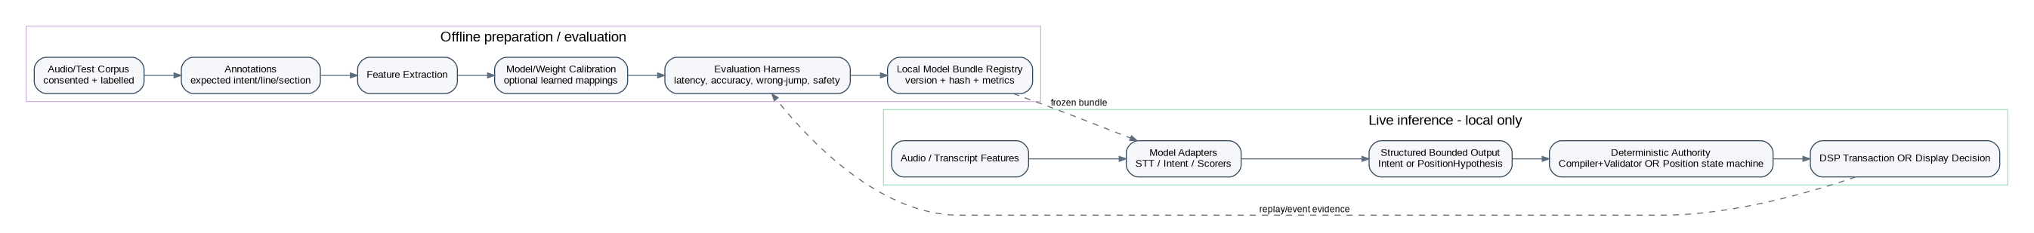
Figure 8. ML lifecycle and live authority boundary
There are two distinct ML problems and they should not share a monolithic model. Blackstar requires speech recognition plus semantic intent interpretation into a fixed schema; LyricPilot requires speech/acoustic feature extraction plus constrained position scoring. Each model bundle must be independently benchmarked, versioned and replaceable behind a stable adapter contract.
ML capability | Inputs | Bounded output | Live authority | Primary metrics
Blackstar STT / intent | command audio, transcript, current context | BlackstarIntent v1 | None; compiler + validator decide | command accuracy, intent exact-match/F1, p95 latency, malformed/unsafe output rate
Blackstar tone matching | reference audio features, tone library embeddings | ranked candidate tones + evidence | User auditions/saves; validator applies later | retrieval precision, perceptual ranking, latency
LyricPilot position scoring | partial tokens, phonetics, acoustics, timing, prior, Song Map window | PositionHypothesis v1 | State machine + jump protection | readiness >=99%, p95 <=250 ms, wrong jumps <1/10h
Rehearsal adaptation | accepted user corrections/history | versioned proposal/weights | Explicit approval before lock | replay improvement without regression

6.1 Model bundle schema
{
"ml_schema_version": "1.0",
"principle": "Probabilistic components produce bounded evidence; deterministic authorities commit live actions.",
"blackstar_intent_model": {
"inputs": [
"transcript",
"performance_context",
"current_tone_summary"
],
"outputs": "BlackstarIntent v1 only",
"prohibited_outputs": [
"raw DSP writes",
"untyped commands"
],
"metrics": [
"intent exact-match",
"ontology-delta F1",
"unsafe-output rate",
"p95 inference latency"
],
"gating": "schema valid AND confidence policy satisfied; then deterministic compiler + validator"
},
"lyricpilot_position_model": {
"inputs": [
"partial tokens",
"token timing/confidence",
"phonetic features",
"acoustic features",
"prior position",
"SongMap candidate window",
"tempo/timing",
"rehearsal history"
],
"features": [
"transcription_similarity",
"phonetic_similarity",
"word_order_score",
"position_prior",
"tempo_alignment",
"history_prior",
"section_distance"
],
"outputs": "PositionHypothesis v1",
"commit_authority": "state machine + jump-protection policy",
"metrics": [
"next lyric readiness >=99%",
"p95 update latency <=250ms",
"incorrect section jump <1/10 live hours",
"zero blank screens over >=2h"
]
},
"model_bundle": {
"required_metadata": [
"model_id",
"model_kind",
"version",
"checksum",
"training_or_calibration_data_version",
"feature_schema_version",
"evaluation_metrics",
"device_profile",
"approval_status"
],
"deployment": "local, preflighted, checksummed, frozen during Performance Lock"
}
}

7. Interface and event contracts
Contract | Required fields | Compatibility rule
BlackstarIntent v1 | intent_id, timestamp, semantic_deltas, locks, context, confidence, requested_action, source, model_id | Additive optional fields only within v1; reject unknown required semantics
ProposedDSPTransaction v1 | transaction_id, base_preset_version, parameter/routing/monitor changes, safety metadata, compiler_version | Atomic and idempotent; base version required
ValidationResult v1 | accepted, violations, confirmation_required, safe_transaction_hash | Only accepted result may reach apply path
DSPApplyResult v1 | transaction_id, applied_version, ack/nack, latency_us, rollback_token | Ack must identify immutable resulting version
SongMap v1 | song_id, version, sections, lines, variants, aliases, graph, tempo/key, checksum | Repeated lyrics have distinct IDs; checksum frozen in lock
PositionHypothesis v1 | song/line/section IDs, confidence, runner-up margin, evidence scores, state, timestamp | Candidate IDs must resolve to approved Song Map
PositionDecision v1 | action, committed_line_id, reason_code, confidence, timestamp | Only this event drives display reducer
PerformanceEvent v1 | event_id, source, topic, sequence, event_time, schema_version, payload, idempotency_key | Consumers must be idempotent and detect gaps/out-of-order sequence

8. High-level technical deployment architecture
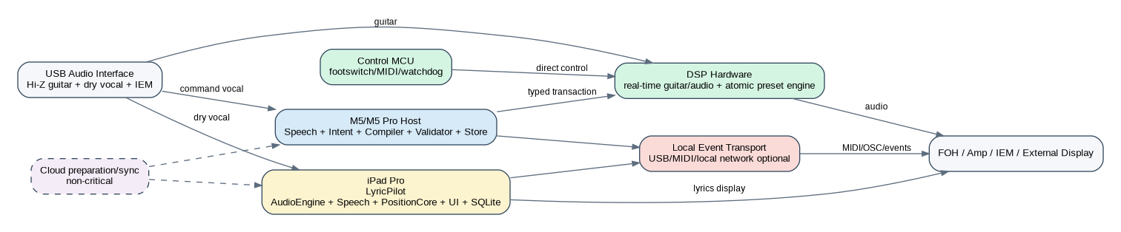
Figure 9. POC / reference deployment architecture
Node | Runs | Must not run
iPad Pro | LyricPilot AudioEngine, SpeechFeatures, PositionCore, Display, local DB, EventBusAdapter | Cloud-dependent live tracking; generative lyric production
M5/M5 Pro host | Blackstar speech/intent adapters, ontology, compiler, validator, event store, simulator/tools | Real-time guitar callback
DSP | guitar processing, preset transactions, crossfade/atomic apply, telemetry | LLM/STT/model inference
Control MCU | footswitch/MIDI fast path, watchdog, mute/recovery, safe boot | General-purpose AI
Optional cloud | library enrichment, sync, ideation, Song Map drafting/rehearsal assistance | Any dependency required to complete a live show action

9. Security, privacy and safety architecture
- Performance Lock is a central policy state consumed by UI, data stores, model management, command routing and validators; it rejects edits, downloads and model swaps during a show.
- Local secrets use platform secure storage; sensitive database fields use encryption where appropriate; logs redact tokens and unnecessary lyric/audio content.
- Every asset in a show manifest has a cryptographic checksum. Entry to Performance Lock fails closed if a required model, preset, IR, Song Map or other asset is missing or mismatched.
- DSP validation is default-deny for unknown parameters, out-of-range values, locked attributes, prohibited routing and safety-critical ownership.
- Audio capture for evaluation is opt-in and separated from operational telemetry. Replay bundles should support selective redaction/deletion while preserving engineering timing data.

10. Observability and replay model
Trace stage | Blackstar evidence | LyricPilot evidence
Input | wake/VAD/STT timestamp + transcript confidence | audio buffer timestamp + input health
Probabilistic output | intent model/version/confidence | partial tokens, feature vectors, candidate scores
Deterministic decision | compiler version + explanation trace + validation result | state transition + jump rule + PositionDecision
Actuation | transaction ID + DSP ack/nack + latency + rollback token | display state + lead time
Recovery | undo/restore event and resulting preset version | manual/degraded/relaunch checkpoint state

11. Build sequence and architecture gates
Sprint / gate | Architecture deliverables | Evidence required
Sprint 0 / G0 | Freeze v1 contracts; repos/CI; ontology v0.1; SongMap schema; DB migration 001; DSP simulator; replay corpus format | Contract tests; ADRs; connected POC rigs; baseline latency/thermal measurements
Sprint 1 | Blackstar text->intent stub->compiler->validator->DSP sim; LyricPilot recorded audio->features->candidate matcher->display; shared event store | Deterministic end-to-end replay without cloud
Sprint 2 | Local STT/model adapter; real DSP bridge; footswitch fast path; Lyric jump protection/uncertainty; USB audio; MIDI | Preliminary KPI report + failure injection
Sprint 3+ / G2-G3 | Musician-language benchmark; tone matching spike; live singing POC; hardening | Formal gate report against latency, safety, readiness and wrong-jump targets
Post-MVP / G4 | Event bus integration, hardened recovery, external display/stage system mappings | Two-hour show tests; idempotency/out-of-order event tests

12. Architecture decision records
ADR | Decision | Reason
ADR-001 | No generative AI in real-time audio path | Protect latency and determinism
ADR-002 | Independent DSP and MCU fail-safe domains | AI host failure cannot interrupt core performance
ADR-003 | Model-agnostic, schema-validated Intent API | Allows model replacement without widening DSP authority
ADR-004 | Tone Compiler is pure and deterministic | Enables golden tests, reproducibility and explainability
ADR-005 | Local assets frozen during Performance Lock | Eliminates surprise changes and cloud dependencies
ADR-006 | Lyric tracking is constrained sequence alignment | Prevents invented lyrics/open-ended jumps
ADR-007 | PositionCore independent of UI/audio hardware | Makes replay testing and deterministic evaluation possible
ADR-008 | Repeated lyric text has distinct identities | Allows correct section disambiguation
ADR-009 | Event Bus optional for first releases | Prevents cross-product integration becoming a V1 blocker
ADR-010 | M5 hardware is POC/reference only | Keeps production compute/electronics decision open

13. Key architecture risks and mitigations
Risk | Architecture mitigation | Validation
Stage noise reduces speech accuracy | direct command mic, wake/VAD, restricted fast grammar, local model benchmark | noise/ad-lib corpus
Repeated chorus causes wrong lyric jump | bounded candidate window, section graph, distance penalty, hysteresis, two-hit distant jump | adversarial labelled corpus + live hours
AI load affects audio latency | physical separation of DSP; no inference/allocations/locks in audio callback | max-load loopback p95 <5 ms
POC compute differs from production | hardware abstraction + stable contracts | swap simulator/target adapters without domain changes
iPad interruption/disconnect | source state machine + persistent last committed state + manual fallback | cable pull, interruption, relaunch tests
Schema drift | single contracts repo + compatibility tests + versioned migrations | CI contract matrix

14. Architecture Definition of Done
- Every cross-module message has a versioned schema and at least one golden fixture.
- Every probabilistic output is bounded and passes through an explicit deterministic authority before live actuation.
- Blackstar audio and physical switching survive AI-host and network failure without audible interruption.
- LyricPilot remains useful under low confidence, audio loss and restart; it never blanks the screen because the tracker is uncertain.
- Every applied DSP transaction and committed lyric position can be reconstructed from event evidence and versioned assets.
- Performance Lock preflight verifies all mandatory local assets and freezes mutable show state.
- POC acceptance metrics are generated automatically from repeatable corpora/harnesses rather than subjective demonstration alone.

15. Recommended repository layout
blackstar-performance-platform/
contracts/
packages/speech/
packages/intent/
packages/tone-ontology/
packages/tone-compiler/
packages/validator/
packages/dsp-bridge/
packages/performance-domain/
packages/event-store/
packages/event-bus/
simulators/dsp/
tests/golden-intents/
tests/failure-injection/
tools/latency-harness/

LyricPilot/
App/
Packages/AudioEngine/
Packages/SpeechFeatures/
Packages/PositionCore/
Packages/SongMap/
Packages/DisplayEngine/
Packages/CommandRecognizer/
Packages/MIDI/
Packages/EventLog/
Packages/EventBusAdapter/
TestCorpus/
Tests/Unit/
Tests/Replay/
Tests/Soak/

performance-contracts/
json-schema/
protobuf/
fixtures/
compatibility-tests/

Appendix A. Source alignment
This plan is an engineering expansion of the uploaded Blackstar PID. It preserves the PID's explicit decisions: two independently gateable products; local-first live operation; deterministic safety boundaries; SQLite for the Blackstar POC event/performance store; native Swift/SwiftUI modularity for LyricPilot; a model-agnostic intent API; constrained Song Map position tracking; and an optional shared Performance Event Bus.

